Project Report

Name:-Prakriti Haldhar
Registration number:-26MIM10199
Course Name:-Introduction to Problem solving

INTRODUCTION

Small description:
Project name is Currency converter. This project convert money of one currency to another. In this project, the concept of python like function, operators, Conditional statement , Loops and many more concepts are used. I had use top down design and many more things. This Project comes in financial category. This project aims the real life problems like people wants to know how much "amount in any currency" can be in other currency .Project's objective is to help people who travel from one country to another for any purpose. Those people can use this project to know how much money of specific currency is in another currency which may help them in transaction and many more. I had applied maximum concept of vityarthi in this project .This project is user friendly tooo that is we don't need to execute whole program after each output of converted currency.I had tested this project and this project is perfectly executable.
PROBLEM STATEMENT

Problem Title:Simplifying Cross-Border Financial Management and Currency Conversion for International Travelers and Professionals
Problem statement for my project is simple and easy.Its a mini project which is easy to use.So the problem statement is: International travelers, students, and professionals frequently struggle to make quick, accurate currency conversions during cross-border transactions. Relying on manual calculations or poorly designed tools often leads to financial errors, budgeting friction, and poor usability—especially when users need to perform multiple consecutive conversions without constantly restarting the program interface. Furthermore, basic programmatic tools often lack a modular, well-structured architecture, making them hard to maintain, expand, or integrate with real-time conversion rates.

Approach

The approach of this project is easy and simple .I had watched people struggling to convert one currency to another. I got idea of this project after observing those people.This project aims real life problem like people wants to know how much "amount in any currency" can be in other currency. This project targets real life problem no doubt. This project is user friendly too. I had clear objective that is to help people who travel from one country to another for any purpose. Project outcome is that its return converted value of currency in different kind of currency .This project is user friendly tooo that is we don't need to execute whole program after each output of converted currency .I had applied most of the concept I learnt during classes. I had used concept of python language like functions, conditional statements ,loops, Boolean value, break statement ,printingstatement ,Operator ,Return statement and many more..

Implementation

The implementation of aiming , planning, coding, testing, documenting on this project was not that piece of cake but not that hard. The perfect planning makes this project’s implementation easy. I had followed structured development process like aiming , planning, coding, testing, documenting. I had first decided what project is about, how this project will overcome real life problem, what is the aim of the project. Secondly, I had planned how this project is going to done ,made algorithm and flowchart before coding process. Then I had started with coding process that was easy part for me because algorithm and flowchart helped me a lot. Now after coding there is a testing part, This project passed testing by showing perfect output as expected. At last I had done documentation. Above content is how I implemented process . Since this project is not that difficult. So implementation was easy.

Results

The result of this project is exact and correct. The output of this came correct as expected. Below is the Screenshot of output of project:

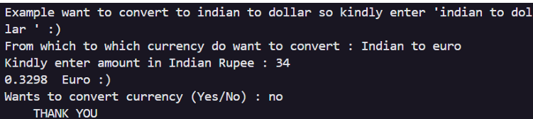

Here is the steps with screenshot of how to execute this project:

Step-1:Run the program
Step-2:You will see as below screen in your screen.
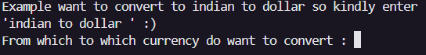
Step-3:Now enter from which currency to which currency you want conversion of currency.
Example: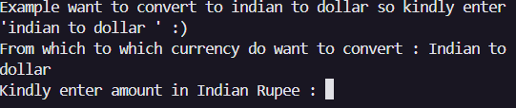
Step -4:Now it will how much money in specific currency you want to know in another currency.
Example: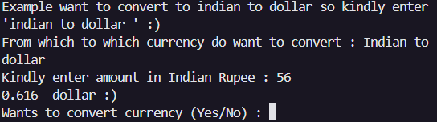

Step-5: Since project is user so u don’t have to execute project/code again for another new conversion of currency. 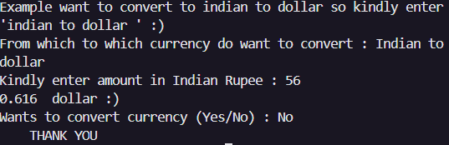

Testing Approach

This is the testing approach for our project:
Step-1:Run the program
Step-2:You will see as below screen in your screen.
Step-3:Now enter from which currency to which currency you want conversion of currency.
Example:
Step -4:Now it will how much money in specific currency you want to know in another currency.
Example:

Step-5: Since project is user so u don’t have to execute project/code again for another new conversion of currency.

Analysis

I had analysis that this mini python project will help many people who love travelling across country.
Since this project objective is to help people who travel from one country to another for any purpose. Project outcome is that its return converted value of currency in different kind of currency .This project is user friendly tooo that is we don't need to execute whole program after each output of converted currency .I think this project achieve its main objective/aim.

Identify a real-world problem or need

This project aims real life problem like people wants to know how much "amount in any currency" can be in other currency. This project targets real life problem no doubt. This project is user friendly too.

Define clear objectives and expected outcomes

Project's objective is to help people who travel from one country to another for any purpose. Project outcome is that its return converted value of currency in different kind of currency .This project is user friendly tooo that is we don't need to execute whole program after each output of converted currency .

Apply concepts learned in the course to design the solution

I had applied most of the concept I learnt during classes. I had used concept of python language like functions, conditional statements ,loops, Boolean value, break statement ,printingstatement ,Operator ,Return statement and many more..

Follow a structured development process

I had followed structured development process like aiming , planning, coding, testing, documenting. I had first decided what project is about, how this project will overcome real life problem, what is the aim of the project. Secondly, I had planned how this project is going to done ,made algorithm and f lowchart before coding process. Then I had started with coding process that was easy part for me because algorithm and flowchart helped me a lot. Now after coding there is a testing part, This project passed testing by showing perfect output as expected. At last I had done documentation.

Challenges Faced

A problem is a task defined by its inputs, desired outputs, and constraints, which can be solved with an algorithm, It's often viewed as a function that maps inputs to outputs, and computer science is the study of algorithms that solve these problems, including those that may not have a solution. In this project ,itresolve the problem of converting currency by convert currency from one currency to another by doing two to three clicks.

FUTURE ENHANCEMENT

The future enchancement for my Project is simple and effect.Enchanement could be done in future.Enhance Could be integrating the Project with UI(Userinterface using TKINTER) Or integrate AI i.e. can develop AL Chatbot.More enhancements can be done in future.

References

Concept learned by Sumita Aurora

THANK YOU THAT ALL FOR PROJECT FILE

